COVID-safe workplaces - #GreaterTogether
Social posts
The social assets (including animated GIFs and static social cards) can be downloaded here:
https://we.tl/t-CrPCixYqQE
Please note that the download link will expire on 9 November.
National Lockdown – Twitter, LinkedIn & Facebook  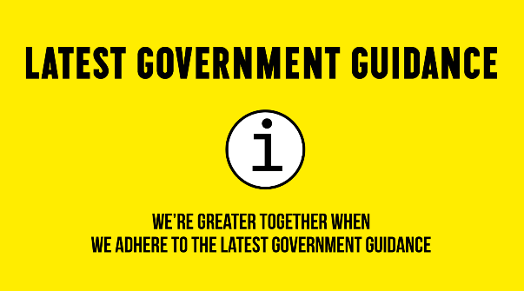 | The national lockdown commences on 5 November – review the @bizgrowthhub easy-read guide with all the latest information on what this means for business  https://bit.ly/2TN85ua  #GreaterTogether #HereforBusiness
Job Retention Scheme – Twitter, LinkedIn & Facebook  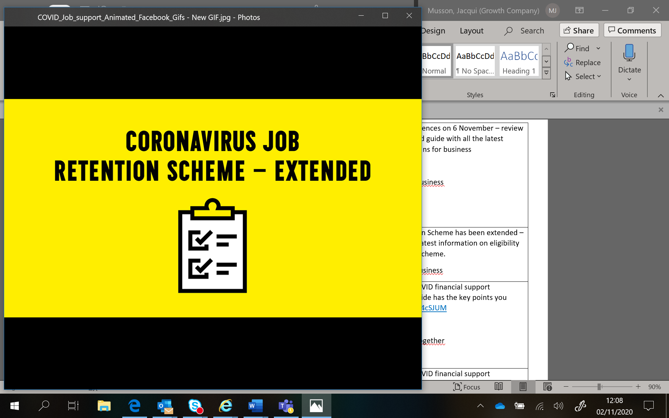 | The Coronavirus Job Retention Scheme has been extended – the @bizgrowthhub has the latest information on eligibility and how you can access the scheme. https://bit.ly/3efhCDS  #GreaterTogether #hereforbusiness
Financial Support - Twitter  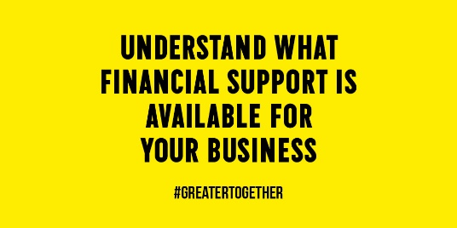 | The @bizgrowthhub here for businesses dealing with the impact of COVID-19. Get in touch or visit our website for impartial support and financial guidance. Find out more:  https://bit.ly/383TT8E  #hereforbusiness #GreaterTogether
Financial Support - Facebook/LinkedIn | The GC Business Growth Hub are here for businesses dealing with the impact of COVID-19. Get in touch or visit our website for impartial support and financial guidance. Find out more: https://bit.ly/383TT8E  #hereforbusiness #GreaterTogether
Here for Business – Twitter   | Need advice on operating during lockdown? Get in touch with @bizgrowthhub to access a range of tools and resources or connect with our team of business advisors for tailored support: https://bit.ly/3oQBzpi  #hereforbusiness #GreaterTogether
Here for Business – LinkedIn & Facebook | Need advice on operating during lockdown?  The GC Business Growth Hub can help you secure appropriate finance and funding, empower your employees, protect your supply chains and effectively engage your clients.  Get in touch to access a range of useful tools and resources or connect with our team of business advisors for tailored support: https://bit.ly/3oQBzpi  #hereforbusiness #GreaterTogether
Travel – Twitter, Linked & Facebook  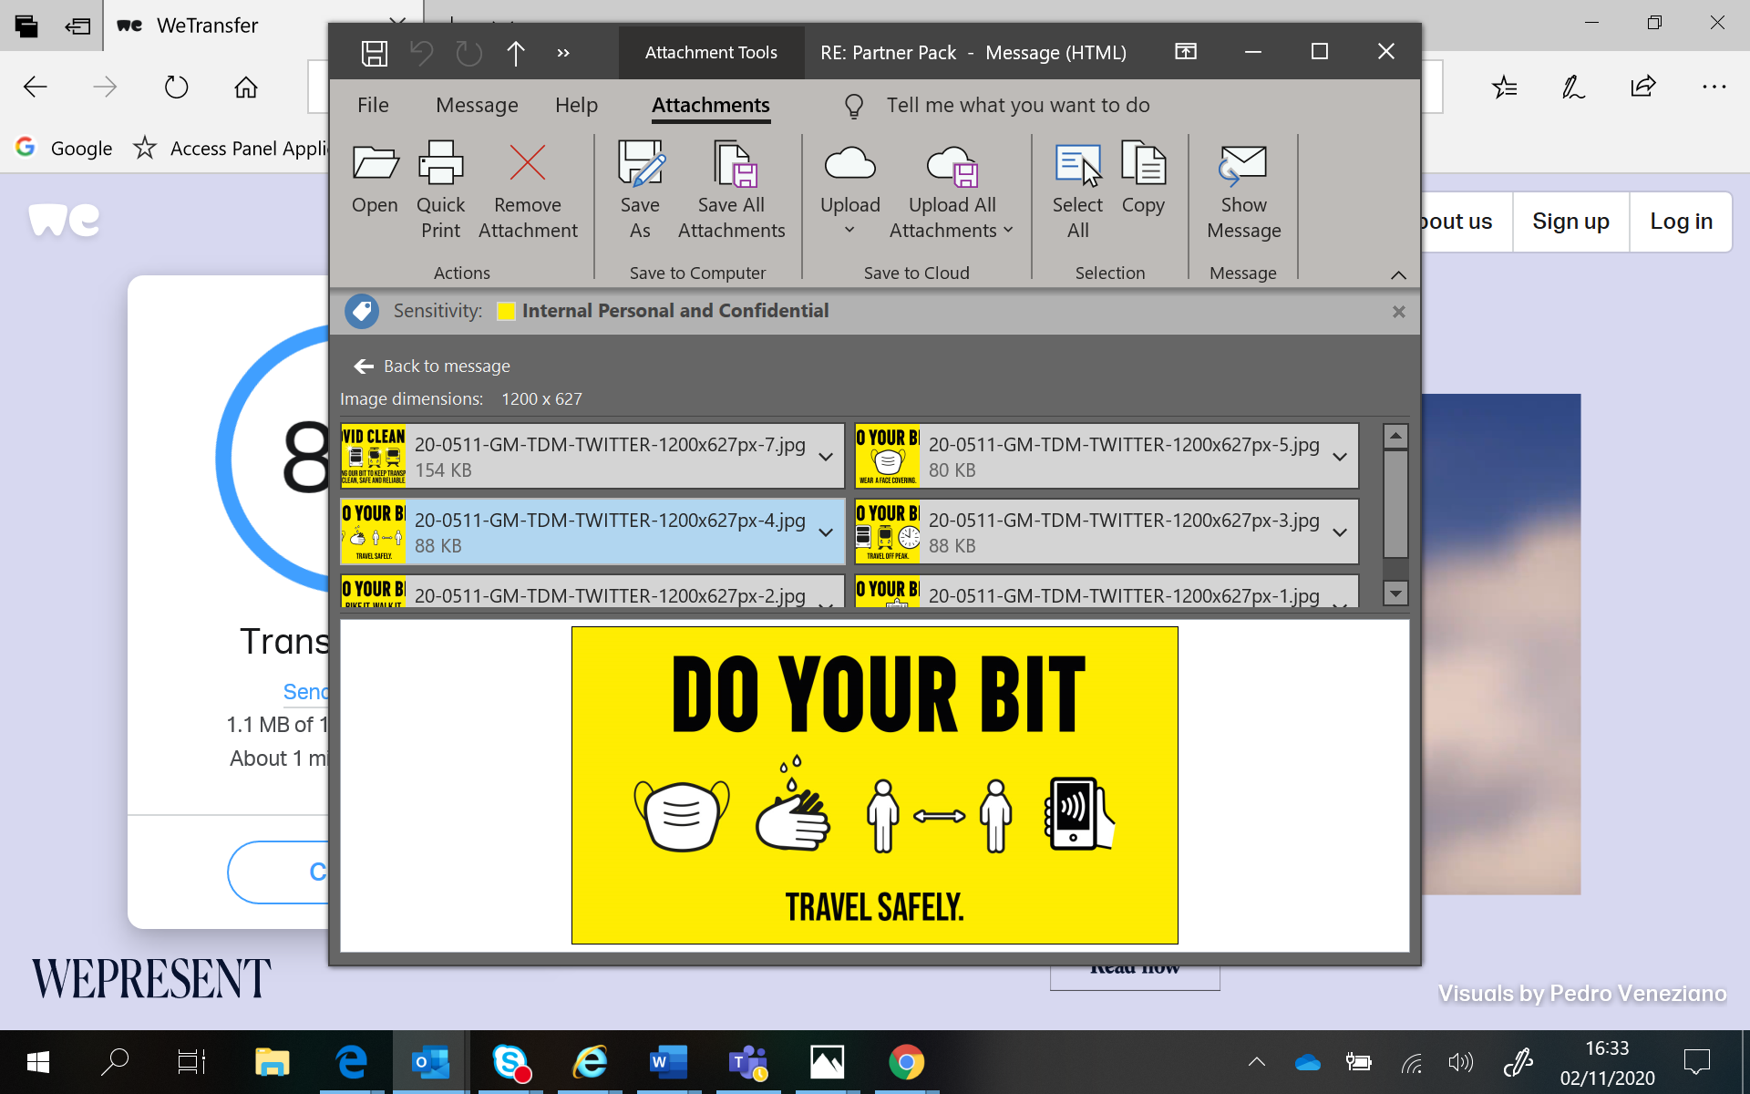 | We all need to play our part in keeping everyone safe as we travel around Greater Manchester. For the latest travel advice and guidance visit www.tfgm.com  #GreaterTogether

